
https://atlas.cid.harvard.edu/

Optimal Industry Development Strategy Using Economic and Product Complexity

Greece

─
The Economic Complexity Lab - Columbia University
Alexandra Garcia, Margarita Demkina, Kelly Mi, Allison Lin, Helena Yang, Jane Zhang, Daniel Xu, Ryo Shibata, Haoxian Chen, Davepriyan Gunaratnam, Rohan Macherla, Ajit Akole, Shomik Ghose, Alex Wei-Liang Ku, Sannidhya Modi, Xilin Wang
Optimal Industry Development Strategy for Greece

0. Executive Summary

In this report, we aim to uncover the economic path Greece went through during the period from 2013 to 2018. Specifically, we dive into the topic through a macroeconomic overview of Greece from the perspective of Gross Domestic Product (GDP) and Economic Complexity Index (ECI), which reflect countries’ production capability and production structure, respectively. We find that during the period of our interest, Greece demonstrated a low level of economic growth with an annual GDP growth rate of -1.7%, concurrent with a decrease in economic complexity as compared with other major economies in Europe. Inversing the pattern, average annual GDP growth increased to 2.19% between 2019 to 2021, similarly to other major economies, but economic complexity increased, diverging from the pattern observed for other major economies.

The level of economic progress during the period, we believe, can be partially explained through analysis of the economic and product complexity structure of Greece on the industry group level. The product classification system we adopt allows us to measure the realized industry development for various industry groups and to observe that Greece invested heavily in developing Chemical Manufacturing, Precious Stones and Metals during the 2013-2018 period, while its emerging peers and developed economies around the globe have adopted much more complex and progressive paths. The three years following showed a significant improvement in Greece’s economic growth, boosting its position on the global scale. Its GDP recovered to above the pre-pandemic levels, and it saw a significant boost in the ECI, particularly compared to its peer countries. Its current strategy still has the viable potential upside to increase its performance and optimize its structure further.

Based on our analysis of the opportunity gain and a sensitivity analysis of major industry groups for 2013-2018, Greece could further its gains by prioritizing Chemicals, Services and Utilities. We further note that Greece has a slightly mismatched development strategy that indicates an increasingly high level of structural optimality on the complexity level, having an adjusted R-square of around -1.3% in 2018 and 21.54% in 2021. Since a significant positive correlation exists between five-year GDP growth and the structural optimality index of an economy as we define and calculate, Greece indeed has a improved its growth experience as compared with fast-growing economies both on a regional scale and on a global scale, but has the potential to further its economic gains through industrial structure optimization as suggested in the paper.

1. Report Overview

In this report, we aim to uncover the economic path Greece went through during the period from 2013 to 2018, and the impact of COVID-19 on its economic development as observed in 2021. Specifically, we dive into the topic through a macroeconomic overview of Greece from the perspective of Gross Domestic Product (GDP) and Economic Complexity Index (ECI), which reflect countries’ production capability and production structure, respectively. We then analyze the industrial framework and changes of Greece during the period based on quantitative measures such as Product Complexity Index (PCI) and Product Family Complexity Index (PfCI), followed by a detailed analysis of how such changes have matched with development strategies as quantitatively measured by opportunity gains on an industry-level. We conclude our report with macro-level results and predictions of Greece, as deduced from regression models we have established on a global scale, which take into account countries’ stances in their product space.

2. Macroeconomic Results

2.1 GDP Ranking and Changes
As the 50th largest economy in the world by GDP, Greece has a GDP of 212 billion USD in 2018 and 216 billion USD in 2021, exhibiting a slightly increasing level of economic output that counters the pattern observed in 2013-2018. Figure 1a illustrates the time-series GDP results for world’s leading European economies from 1999-2018, and Greece ranks among its counterparts as a stable player. During the period from 2013 to 2018, Greece exhibited an average annual GDP growth rate -1.7%. This rate is clearly below the annual growth rate of the group of major European economies in the world, which have a geometric average growth rate of 0.6% and an arithmetic average growth rate of 0.9%. The stagnated economic growth in Greece during the 2013-2018 period, we believe, can be reflected through consistent ECI and PCI, and can be further explained by a suboptimal set of production strategies Greece adopted during the period, which we will expand at the later stage of the report.

Figure 1b illustrates the time-series GDP results in 2019-2021. Similar to peer countries, Greece displayed slight upward growth over the period, despite a minor observed decrease in GDP in 2020 due to the economic implications of COVID-19. Yet, it displayed a significant overall increase of 3.89% in average annual growth rate, up to 2.19%.

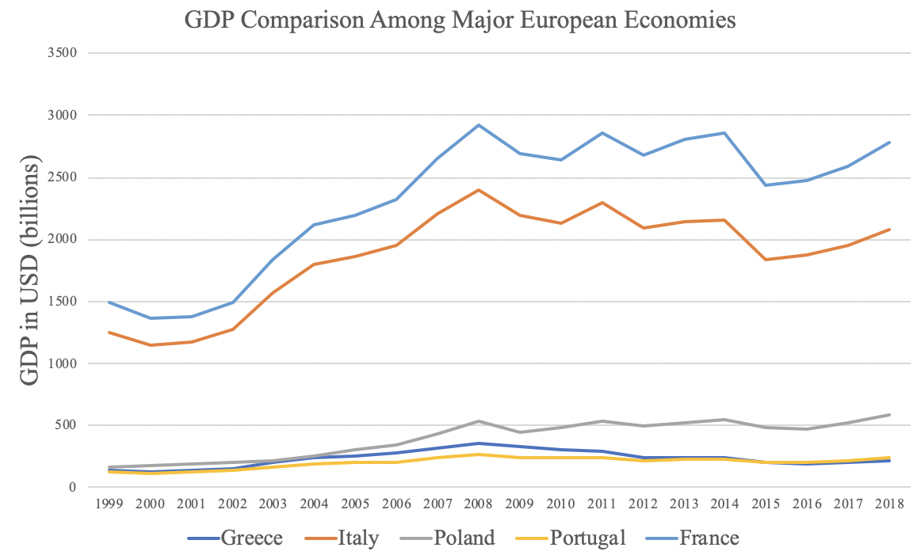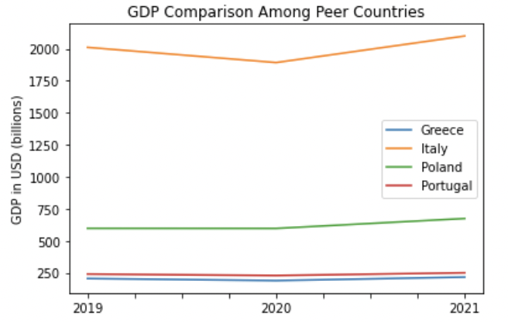
Figures 1a and 1b. GDP Comparison Among Peer Countries (left: 1999-2018; right: 2019-2021)

2.2 ECI Ranking and Changes
The Economic Complexity Index (ECI), as defined by Ricardo Hausmann and Cesar Hidalgo in 2009 to explain the knowledge accumulated in a country's population, exhibits a similar pattern for Greece. As illustrated in Figure 2a below, Greece exhibits a stably low level in terms of its production capability from 2013 to 2018. This is in direct contrast to countries such as France, which demonstrates overwhelming advantage over Greece in terms of both ECI and GDP growth during this period, though Greece’s peers showed mixed performance in ECI. In Figure 2b, for the period 2019-2021, the pattern is reversed: Greece exhibits the only positive ECI change and attains a higher ECI than all of its peers.

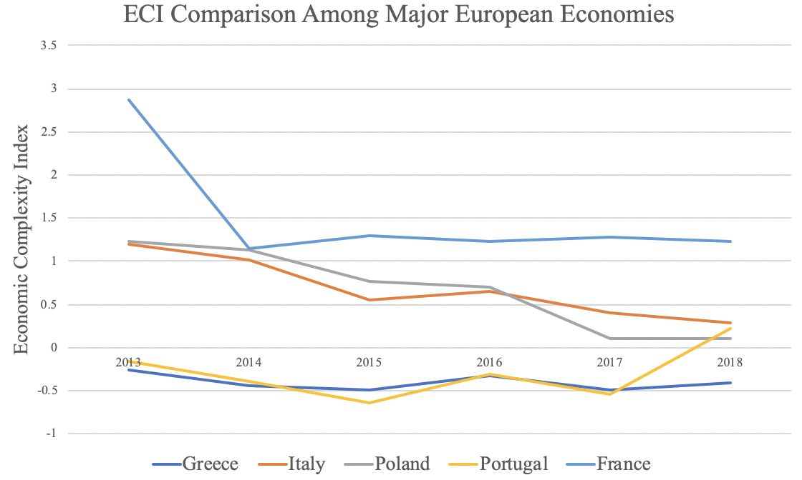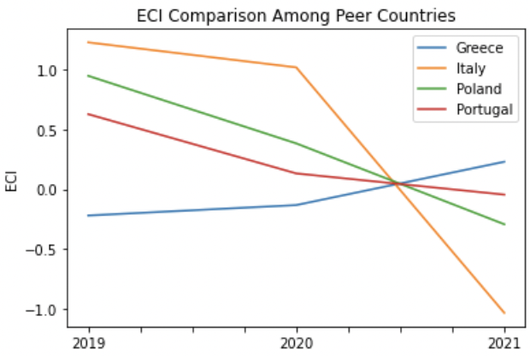
Figures 2a and 2b. ECI Comparison Among Peer Countries (left: 2013-2018; right: 2019-2021)

Figures 3a and 3b offer a further comparison of GDP and ECI over the time span from 2013-2018 and 2019-2021 for Greece, respectively. The stagnancy in GDP during the period from 2013 to 2018 is accompanied by a stagnancy in ECI, indicating the potential that the mild economic growth experienced by Greece during this period might be attributed to its slow-growing ECI, or the ineffectiveness of the country in developing a competitive product space that helps to accumulate complicated knowledge and technology. For the period 2019 to 2021, however, both Greece’s ECI and GDP increased, which can be interpreted as advancements in production. In order to provide a more concrete answer to why this has happened, we will dive into an analysis of Greece’s production structure and its product space designs in the next few chapters.

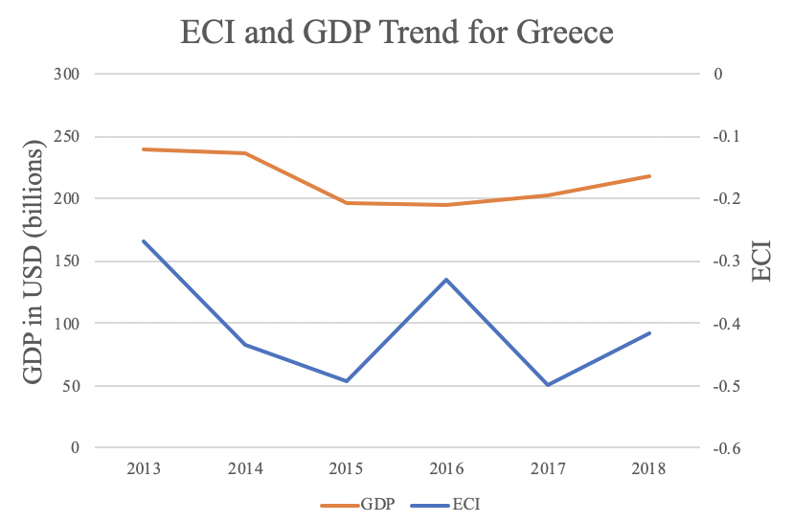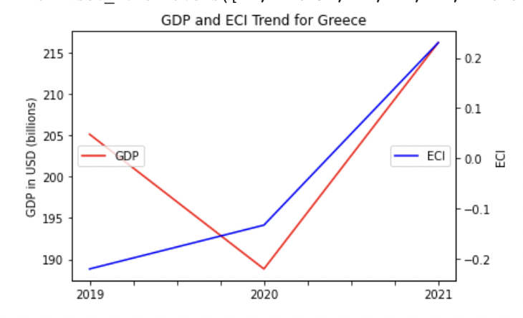

Figures 3a and 3b. ECI Comparison Among Peer Countries (left: 2013-2018; right: 2019-2021)

3. Production Analysis

3.1 Product Categorization
Our main data source in this research is the UN Comtrade Website (https://comtrade.un.org), which provides us with valuable information on countries’ export values on an annual basis, including highly specific export data for more than 5000 categories of products. In order to have a holistic vision of the product space of a country, however, a level of categorization is required. Products in our data source are labeled from 010000-999999, with the first two-digits representing a general category to which the product belongs. Based on the 99 categories as extracted from the label, we further group the products into 18 most widely-accepted industries, as summarized in Table 1.

Note that the High-complexity Products industry group is not a distinct industry but rather an aggregated industry that encompasses the most complicated products from the most technologically-advanced industries (as measured by PCI). This industry serves as an indicator for us to quantitatively evaluate how well a country has performed in developing cutting-edge technologies and closing its technical gap with advanced economies, which has become a topic of wide concern today. Indeed, when we rank the 18 categories based on PfCI (an equivalent concept of PCI as calculated based on the 18 categorized product groups), the High-complexity Products industry has the highest PfCI among all industry groups.

Category | Description
Animals and By-products | All kinds of meat, livestock and related by-products
Vegetables, Fruits and Plants | All kinds of plants, edible vegetables and fruits
Food and Preparations | Edible preparations, raw cooking materials and appliances
Clothing and Accessories | All kinds of fabrics, filament, clothing and accessories
Textiles | All kinds of textile articles and related products
Wood Products | Book, paper and other elementary products related to wood
Metals | Mining of all sorts of raw Metals
Refined and Processed Stones | Refined or processed stone products such as pearl and ceramics
Energy Drilling and Mining | Mining industry for energy, minerals, stone materials, etc.
Daily Instruments | Basic daily instruments such as sport requisites, timing and measuring tools
Raw Manufacturing | Basic products made from plastic, rubber, leather, etc.
Chemical Manufacturing | Advanced chemical products and pharmaceutical products
Chemicals | Raw chemical materials and by-products
Machinery and Construction | Machinery and mechanical appliances, including electrical equipment
Transportation | Vehicles and locomotives including aircraft, ship, railway, etc.
Weapons | Explosives, arms and ammunition
Services and Utilities | Financial, business, legal, communication, travel Services and Utilities, etc.
High-complexity Products | Agglomeration of advanced products with highest PCIs

Table 1: Categorization of Products

We further observe a positive correlation between the GDP and the export of High-complexity Products. A higher adjusted R-square exists between GDP and High-complexity Products exports, indicating that more successful economics, as measured by GDP, tend to be those that are capable of producing and exporting High-complexity Products as we define them. The Figure 3 and 4 show the OLS results in a universe of 107 and 21 typical countries respectively.

 | High-complexity Products | Food and Preparations | Animals and By-products
Adj.R-squared | 0.075 | 0.006 | 0.002
F-statistic | 9.556 | 1.638 | 1.175
No. Observations | 107 | 107 | 107

Figure 3: OLS Regression Results of GDP against Percentage Volume of Exports

 | High-complexity Products | Food and Preparations | Animals and By-products
Adj.R-squared | 0.149 | 0.003 | -0.012
F-statistic | 4.510 | 1.059 | 0.7542
No. Observations | 21 | 21 | 21

Figure 4: OLS Regression Results of GDP against Volume of Percentage Exports

3.2 Realized Industry Development
Based on the product categorization aforementioned, we aim to capture Greece’s realized industry production strategy between 2013 and 2018 on a complexity level. In Hausmann and Hidalgo (2009), distance is defined to be a measure of how far a country is from a certain product not in its product space. We extend this concept to all product groups and quantify how technically equipped a country is to develop the corresponding product groups. In other words, the shorter the distance between a country and a product group, the more capable a country is in developing products within that group. Defining this net distance change as the Realized Industry Development (RID), our export data allow us to calculate and compare RID of Greece and the 18 product groups in 2013-2018 and 2019-2021 through subtraction, where a positive RID indicates a shortening of the distance (i.e., advancement of the industry), and a negative RID indicates the reverse. As ranked in Table 2, during both 2013-2018 and 2019-2021 periods, Greece focused on products with a moderate level of complexity and those requiring intermediate skills.

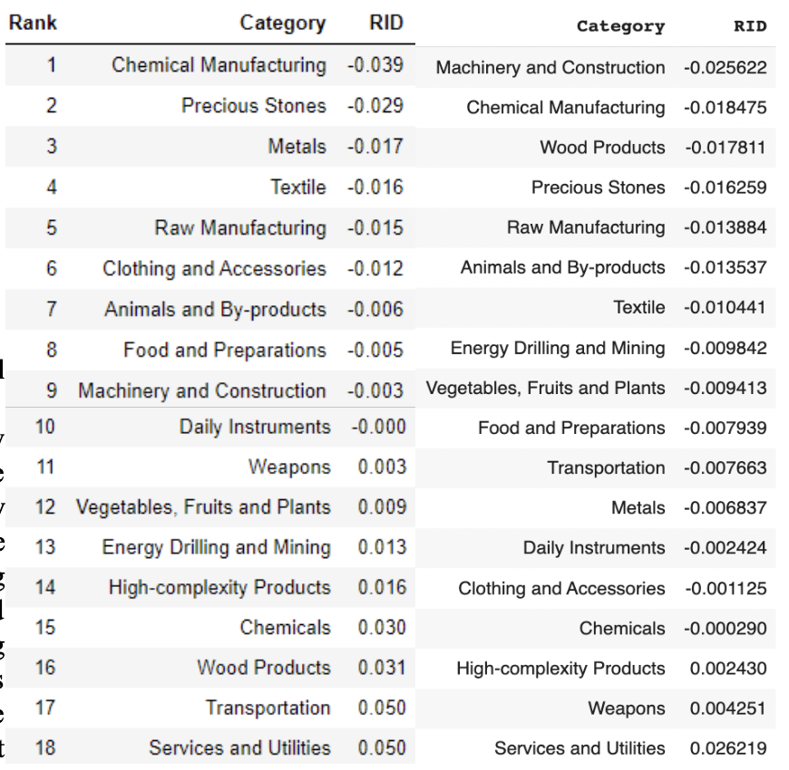
Table 2: Realized Industry Development (RID) of Greece (left: 2018; right: 2021)

3.3 Regional and Global Comparison
Table 3 and 4 below summarize how the production strategy adopted by Greece compares with leading economies and a selected group of emerging economies in the world, as measured in RID. It can be directly observed that Greece focused on products with a lower complexity level, when compared against leading economies such as the United States and Germany, which gave a considerable level of attention to more advanced product groups such as clothing, services and utilities, and chemical manufacturing.

Ranking | France | The United States | Germany
1 | High-complexity Products | Services and Utilities | High-complexity Products
2 | Chemical Manufacturing | Weapons | Transportation
3 | Daily Instruments | Raw Manufacturing | Wood Products
4 | Animals and By-products | Precious Stones | Metals
5 | Food and Preparations | Animals and By-products | Food and Preparations

Table 3: RID Comparison across Leading Economies

Ranking | China | South Korea | Singapore
1 | High-complexity Products | Transportation | Transportation
2 | Transportation | Textile | High-complexity Products
3 | Machinery and Construction | High-complexity Products | Precious Stones
4 | Energy Drilling and Mining | Chemical Manufacturing | Daily Instruments
5 | Daily Instruments | Machinery and Construction | Services and Utilities

Table 4: RID Comparison across Emerging Economies

Table 4 further examines Greece’s development strategy against those of emerging economies on a global scale. Reasonably, emerging economies such as China, South Korea, Singapore and India have devoted the majority of their efforts into intermediate industry groups while developed economies such as Greece should have relied more on advanced industry groups. This trend holds true in general, regardless of the continent or the time period, and serves as an indicator for which phase of development a country is currently in as evaluated from its production strategy. Based on this standard, Greece is indeed adopting a moderate but slightly out-of-phase strategy that seeks development in industry groups with a lower level of complexity than it should.

4. Product Space Design

4.1 Suggested Development Vector
As aforementioned, distance gives us an idea of how far each new product is from a country’s current mix of exports. As defined in Hausmann and Hidalgo (2009), distance is “the weighted proportion of products connected to goods p that country c is not exporting, i.e., MCP=0.” Based on this definition, the distance between a country and any product that the country is currently exporting (i.e., the country is a significant exporter in the product as compared to global average) is zero. Similarly, opportunity gain quantifies the contribution of a new product in terms of opening up the doors to more and more complex products. Intuitively, a product that a country is currently exporting (i.e., MCP=1) has an opportunity gain of zero. And unreasonable investment on certain product p would lead to a relative decrement in export of more profitable products, and therefore lead to a negative opportunity gain of product p. The opportunity gain is not the only estimator of a country’s level of economic development. However, among countries with comparable economic strength, those having higher ECI, or in other words, more reasonable economic structure are often in better shape.

We define the ranking of opportunity gain for a country c, as the Suggested Development Vector (SDV) of c. Table 5 and 6 summarize how the SDV of Greece compares with a selected group of comparable and leading economies in the world, with the industry groups ranked in decreasing order of significance. Dark blue indicates positive opportunity gain, light blue indicates zero opportunity gains, and white indicates negative opportunity gains. The result shows that leading countries barely have any industries with positive opportunity gain. In other words, those countries are already in the most stable and efficient economic structure. Without the necessity of economic transition, those countries merely need to maintain a steady and balanced economic development. In contrast, developing countries have nearly half of industries with positive opportunity gain, and share common interests in industrial manufacturing and High-complexity Products industries. It can be concluded that Greece shares the characters of developing countries, with a balanced economics structure that leans towards intermediate-level industries.

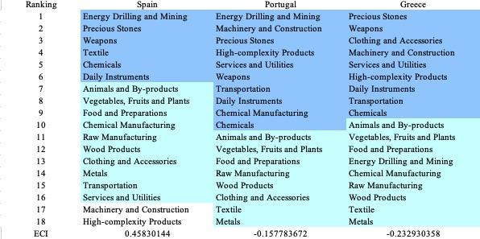
Table 5a. Opportunity Gain Ranking on a Comparable Scale (2013)

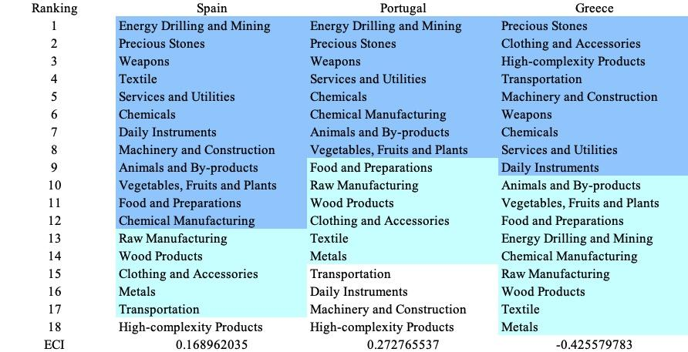
Table 5b. Opportunity Gain Ranking on a Comparable Scale (2018)

Ranking | Spain | Portugal | Greece
1 | Energy Drilling and Mining | Energy Drilling and Mining | Precious Stones
2 | Textile | Precious Stones | Clothing and Accessories
3 | Precious Stones | Weapons | Wood Products
4 | Wood Products | Services and Utilities | Weapons
5 | Weapons | Chemicals | Transportation
6 | Animals and By-products | High-complexity Products | Services and Utilities
7 | Vegetables, Fruits and Plants | Chemical Manufacturing | Chemicals
8 | Food and Preparations | Transportation | Raw Manufacturing
9 | Chemical Manufacturing | Daily Instruments | Daily Instruments
10 | Raw Manufacturing | Animals and By-products | High-complexity Products
11 | Clothing and Accessories | Vegetables, Fruits and Plants | Animals and By-products
12 | Metals | Food and Preparations | Vegetables, Fruits and Plants
13 | Machinery and Construction | Raw Manufacturing | Food and Preparations
14 | High-complexity Products | Wood Products | Energy Drilling and Mining
15 | Services and Utilities | Clothing and Accessories | Chemical Manufacturing
16 | Chemicals | Textile | Textile
17 | Daily Instruments | Metals | Metals
18 | Transportation | Machinery and Construction | Machinery and Construction
ECI | -0.5616917471435152 | -0.045259336646675585 | 0.23035793848767286
Table 5c. Opportunity Gain Ranking on a Comparable Scale (2021)

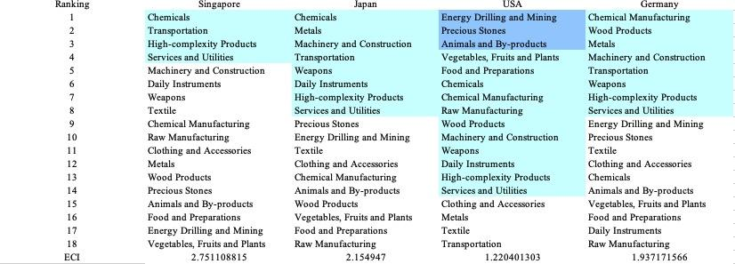
Table 6. SDV of Other Sample Countries (2018)

4.2 Budgeted Industry Development Strategy and Interpretation
The optimal budgeted industry development strategy aims to solve the most efficient allocations under the budgeted constraint of different situations of heuristic total export growth. In order to obtain such an allocation portfolio, we formulate an optimization problem as the following:



where k(x) is the second largest eigenvector of $M_{CC'}$ after adding $x$ to the original export vector, C is the country that we are interested in, P is the product space, B is the heuristic budget.

If we can solve this problem, then we can know what the largest ECI that a country can improve to. Accordingly, the optimal solution $x*$ that we obtain here is exactly our optimal allocation. However, the biggest problem is that the objective function is not convex. Therefore, we cannot apply the classical tools for convex optimization on this problem. In order to solve this problem, our idea is to use greedy algorithm. The way that we apply greedy algorithm is that firstly we separate the total budget into k equal parts, and then for the first equal part we try to search for the product that can optimize our objective function by iterating through each $p∈P$. After we find the optimal product p for this equal part, we add the amount back to the export value of this product p and update the ECI for this country. If we observe that ECI does not change after iterating all the products, then we can add up one more equal part to invest. Until we find there is an ECI increment, we add the amount now to that product. The rest equal parts can be done in the same way.

However, as is known to all, greedy algorithm is a kind of local search algorithm, which is pretty possible to run into a local minimum. Therefore, for local search algorithms, one typical way is to keep it away from the local minimum is to enhance the vision of the algorithm by looking more steps forward. In our setting, whenever we obtain an increment of ECI, we mark down the required amount of export growth. Simultaneously, we continue searching for the next ECI increment point, compare the ratios of these two possibilities and pick the largest one. The ratio is defined as the following:


where ${ECI}_{p}$ is just the ECI of the country after adding some amount of export increment to product $p$, which is exactly the amount that is able to make ECI change. Also, we can express it in the way of $||$$x_{p}-x_{0}$${||}_{1}$.

In this way, we can obtain a further sighted greedy algorithm. Also, the number of parts that we would like to separate the budget into also matters. In order to solve this problem, we added a stabilizer on top of the enhanced greedy algorithm, by running the algorithm for different number of parts and selecting the portfolio with the largest ECI increment and most complex economic structure.

Besides, it is quite common that there is a surplus for the budget. To deal with the surplus, we just add it to the product which needs the least amount of dollar to make $M_{cp}$ = 1, (i.e., the smallest amount of required export increase).

Economic Panel
As stated above, the enhanced greedy algorithm is developed mainly for solving the optimal allocation strategy. In order to visualize this allocation, an economic panel is created, consisting of a pie chart, a line chart and a table. Firstly, a pie chart is used to show the percentage of each product in the optimal portfolio. The number located in the center of the circle denotes the heuristic growth of total export, which is also our budget. For example, for the first pie chart below, it shows we should allocate 25% for food and preparations, animals and by-products, and chemicals. In addition, we should allocate 12.5% for raw manufacturing and chemical manufacturing. The lines below the pie charts show how the ECI changes during the searching process of the greedy algorithm. For example, in the last pie chart, we can see there are three components, but there are four increments in the last line chart. That is just because many equalized amounts have been invested in high-complexity products. Even though sometimes people may feel 15% and 20% is nonsense to developed countries, yet it can also give a sense of how a country should develop in the long term. Eventually, the graph in the end is just for numerical explanation for the pie charts.

Interpretation
Interpretation
For the purpose of a clear explanation of the line charts, we label all the products in Table 7. Please refer to this table when trying to understand the investment trajectories in the line charts.

Label | Product Names
1 | Animal and By-products
2 | Vegetables, Fruits and Plants
3 | Food and Preparations
4 | Energy Drilling and Mining
5 | Chemicals
6 | Chemical Manufacturing
7 | Raw Manufacturing
8 | Wood Products
9 | Clothing and Accessories
10 | Textile
11 | Metals
12 | Machinery and Construction
13 | Transportation
14 | Weapons
15 | Daily Instruments
16 | Precious Stones
17 | High-complexity Products
18 | Services and Utilities
Table 7. Products Labeling

Figures 4a-4c show an economic panel for Greece in 2013, 2018, and 2021. We can see that for different percentages of heuristic total export growth, the ECIs of Greece actually have different increments. From the four line graphs, in all years in question, we see that Greece already obtains some great increment in terms of ECI. Most importantly, the higher the budget is, the greater the ECI will be. This means that in both short term and long term, Greece still has great room to improve.

For 2013, in the case of 5 percent export growth, Clothing & Accessories and Chemicals are the main components. In this case, ECI has already increased so much that it is relatively easy for Greece to develop a higher economic complexity. With a budget of 10 percent export growth, Daily Instruments and Clothing & Accessories account for most of the portfolio. For 15 and 20 percent, extra ECI increments are driven by introduction of Machinery & Construction, although they are relatively small. A more detailed numerical representation of the portfolio is shown in Table 8a.

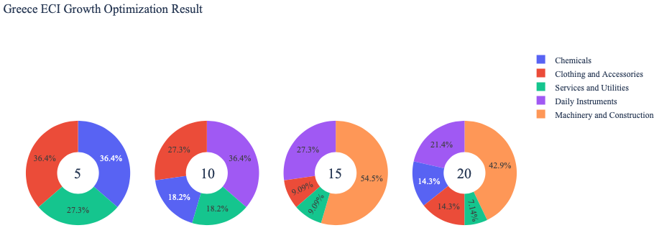
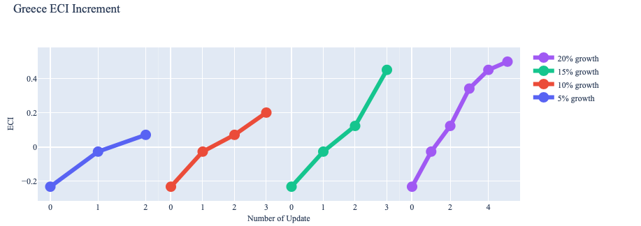
Figure 4a. Greedy-Based ECI Improvement Results of [Country] with Different Budgets (2013)

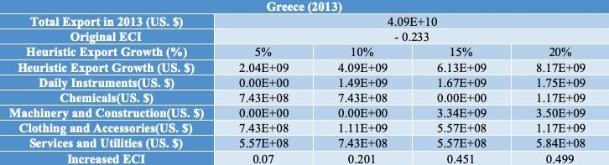
Table 8a. Portfolio of Greece (2013)

For further suggestions on Greece’s development in the future. We also offer the optimization result of Greece based on export data in 2018. Below is the economic panel for Greece in 2018. We can see that for different percentages of heuristic total export growth, the ECI growth pattern of Greece is similar from the one in 2013. For the case of 5 percent export growth budget, the ECI does not increase significantly. The greatest increment in the first line graph is actually driven by Machinery & Construction. For all four cases, it seems that Daily Instruments, Services Industries and Machinery products form the majority of ECI increments. Therefore, for strategy following 2018, Greece should have prioritized development of Services & Utilities as well as Daily Instruments, which was predicted to generate the greatest jump in each stage.

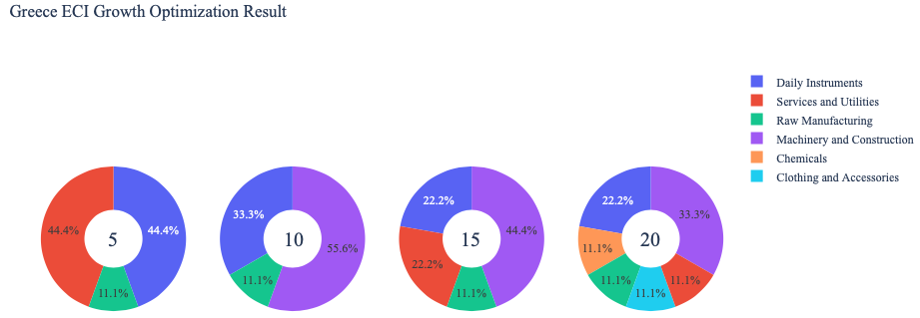
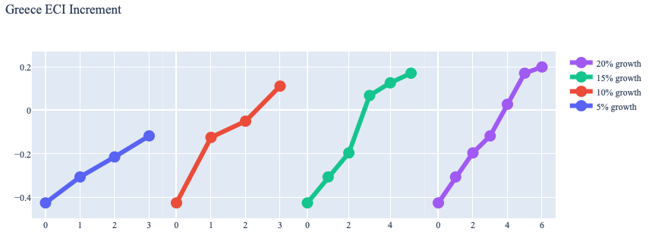
Figure 4b. Greedy-Based ECI Improvement Results of Greece with Different Budgets (2018)

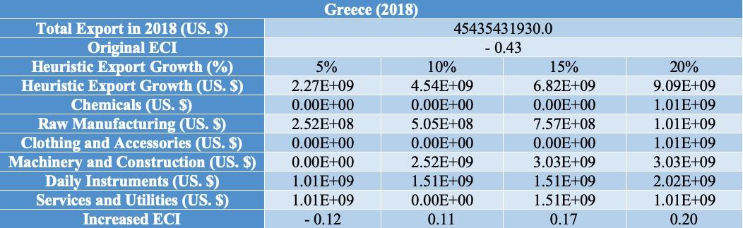
Table 8b. Portfolio of Greece (2018)

To compare with the performance in 2013 and 2018, we also re-examine suggested strategies for 2021. For 2021, a 5 percent increase in export would emphasize Precious Stones, followed by Energy Drilling & Mining and Precious Stones for a 10 percent increase, and Textile for 15 and 20 percent export growth. These strategies go in line with the suggested trajectories based on ECI. A more detailed numerical representation of the portfolio for Greece in 2021 is shown in Table 8c.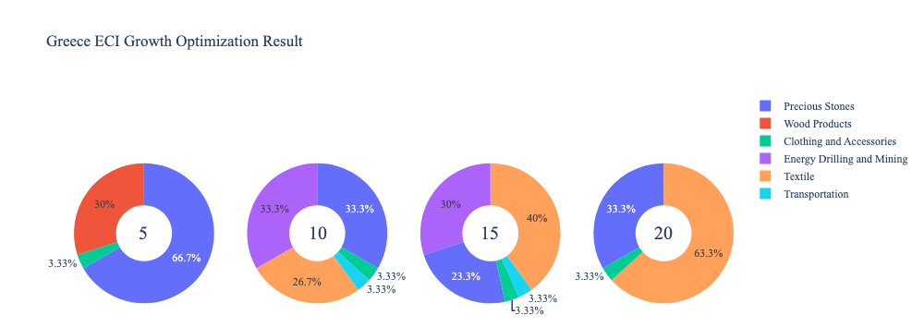

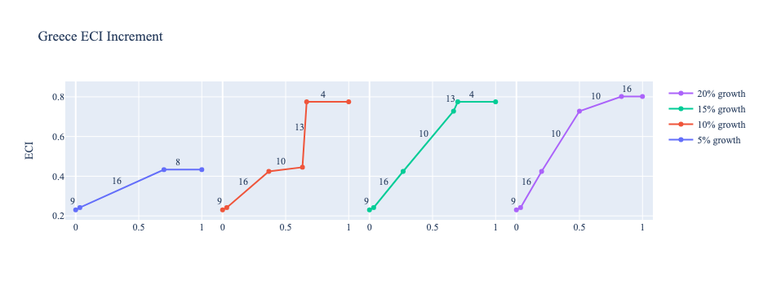
Greece (2021)
Original ECI | 0.23035793848767286
Heuristic Export Growth | 5% | 10% | 15% | 20%
Energy Drilling and Mining | 0 | 3529399238 | 4764688971 | 0
Wood Products | 1588229657 | 0 | 0 | 0
Clothing and Accessories | 176469962 | 352939924 | 529409886 | 941173130
Textile | 0 | 2823519390 | 6352918628 | 1.7882E+10
Transportation | 0 | 352939924 | 529409886 | 0
Precious Stones | 3529399238 | 3529399238 | 3705869199 | 9411731300
Increased ECI | 0.4331096 | 0.7749779 | 0.7749779 | 0.8017798
Table 8c. Portfolio of Greece (2021)

4.3 Sensitivity Analysis
In the following section our broad aim is to understand how sensitive Greece is to changes in export in various industries. While the Economic Complexity Index has been shown to contain valuable information about the economic strength/capacity of a country, little has been said as to the stability of the measure itself. We seek to uncover the main drivers of stability under a country's ECI score and better understand longer-term projections for ECI growth. Additionally, gaining an intuition on the industries that are bolstering an economy and the industries that offer the greatest return per unit of investment is best done through visualization of industry specific sensitivity.
ECI Sensitivity Graph
Firstly, in order to assess the effect particular industries have on each respective country, we developed ECI Sensitivity graphs. We use shocking methodology to increment or decrement an industry’s export level by a certain percentage and recalculate the ECI all else being equal. While freezing the export dynamics of the rest of the world and enacting an instantaneous shock in export for a particular industry and country may not reflect real-life dynamics, what it does offer us is an understanding of a country’s level of dependency on an industry in the context of ECI. The shocking is done in small percentage increments in order to smooth out the resulting curve. Additionally, a recurring theme one will see is that for most industries, a breaking point occurs where the ECI either jumps upwards or downwards, creating a hockey stick shape rather than a linear trend. While the inflection point may not be accurate in context of real life, comparing the various inflection points across industries can give us valuable insight.
The graphs are formulated as follows: There are four ECI Sensitivity graphs. The first two represent data from 2018. The first chart shows positive shocking in which export numbers are shocked upwards per industry. The X-axis is in terms of percentage shock per current dollar value of export. The Y-axis is the recalculated ECI level post-shocking. The second chart follows the same format except the X-axis represents negative shocking. In other words, exports for each industry are decremented and the ECI is accordingly recomputed. The final two sensitivity graphs show the same results using 2013 data. Below is an example of an ECI sensitivity graph.

Figure 5. Example 2018 (Incremental ECI Sensitivity)

SDV Sensitivity
We examine Greece's ECI Decremental and Incremental Sensitivity Charts for 2021. An increase in Daily Instruments will lead to the highest change in ECI, followed by Services & Utilities and High Complexity Products. The strong sensitivity effect of manipulating the High Complexity Products category remains consistent with results from previous years. For the negative shock cases, Weapons become most impactful for increasing ECI, a new trend across the data from previous years. The biggest downturn as a result of a negative shock is observed in Machinery & Construction.

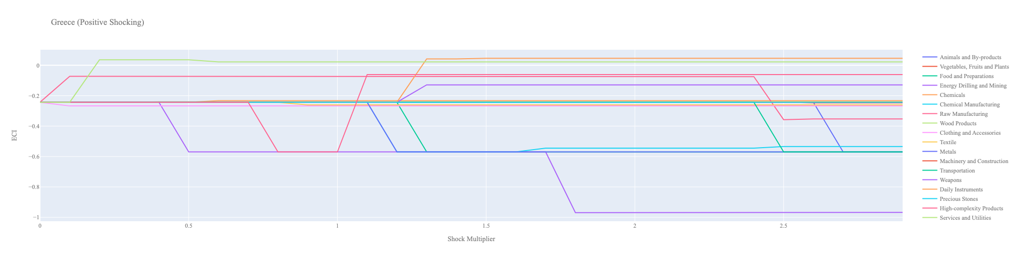
Figure 6a. Greece 2021 (Incremental ECI Sensitivity)

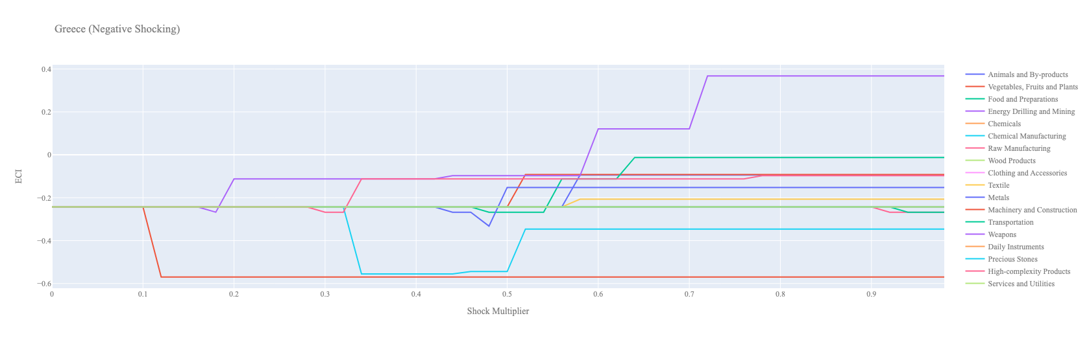
Figure 6a. Greece 2021 (Decremental ECI Sensitivity)

Below is Greece’s 2018 ECI Sensitivity Charts. Firstly in the positive chart, we notice immediately that expanding exports in High Complexity Products and Machinery give fairly significant increases in ECI but require over 100% increase in exports. Weapons and Daily Instruments also allow for ECI gains but the expansion is not as significant as we see with the previous two industries.

Next we consider Greece’s 2018 Negative Shock chart. We can see that Greece is fairly sensitive to Raw Manufacturing, Textile, and Chemical Manufacturing. Even a small decrease in Raw Manufacturing immediately decreases the ECI of Greece. A few other industries lead to positive ECI gains after exports are decreased however over 60% decreases are necessary to experience these gains.

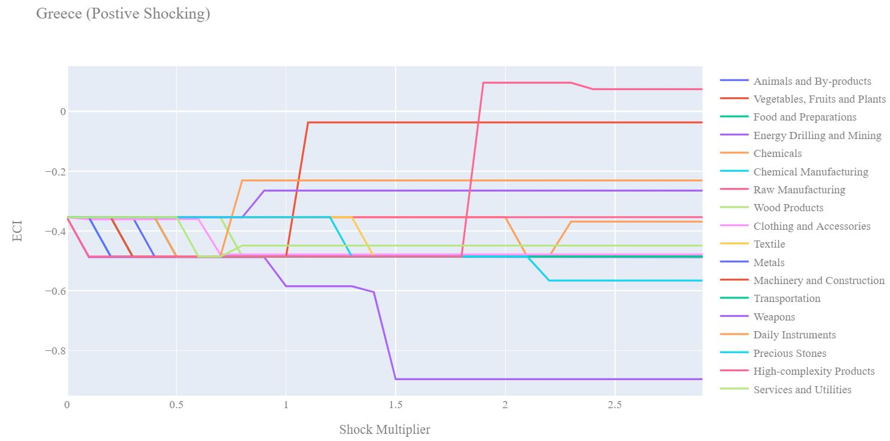
Figure 7a. Greece 2018 (Incremental ECI Sensitivity)

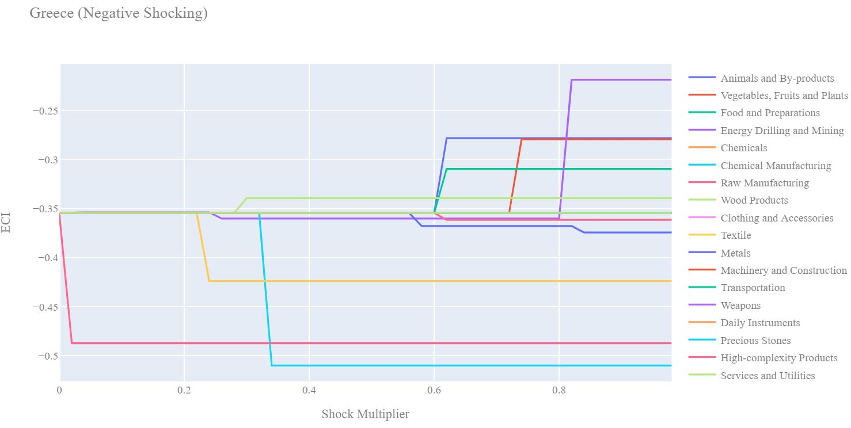
Figure 7b. Greece 2018 (Decremental ECI Sensitivity)

Next we consider the 2013 ECI Sensitivity graphs. We see that in the positive shocking case increases in exports of High Complexity Products, Machinery lead ECI gains but require over 200% expansions, a highly unrealistic number. Services and Utilities offer modest ECI gain with approximately 75% increases in export.

In the 2013 negative shocking case, we see that again Greece is fairly sensitive to decreases in export of Raw Manufacturing, Textile, and Chemical Manufacturing similar to what we see in the 2018 case. There is also some sensitivity to drawdown in Metals as well in the 2013 graph which is less pronounced in 2018.

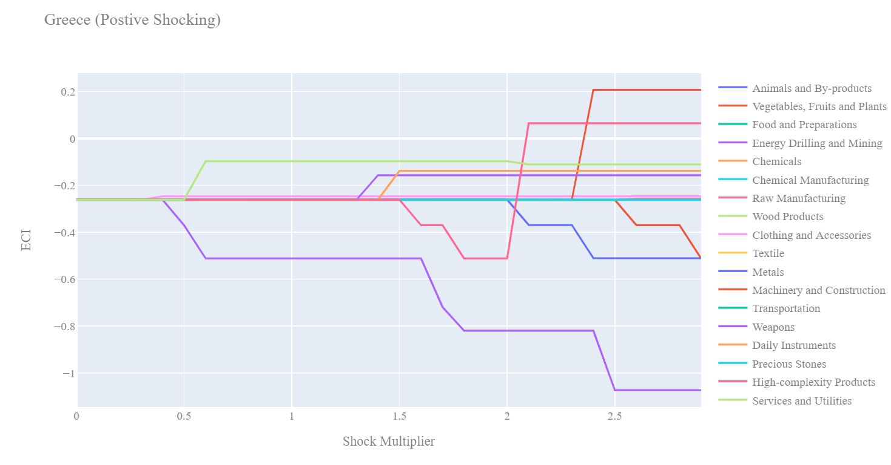
Figure 8a. Greece 2013 (Incremental ECI Sensitivity)

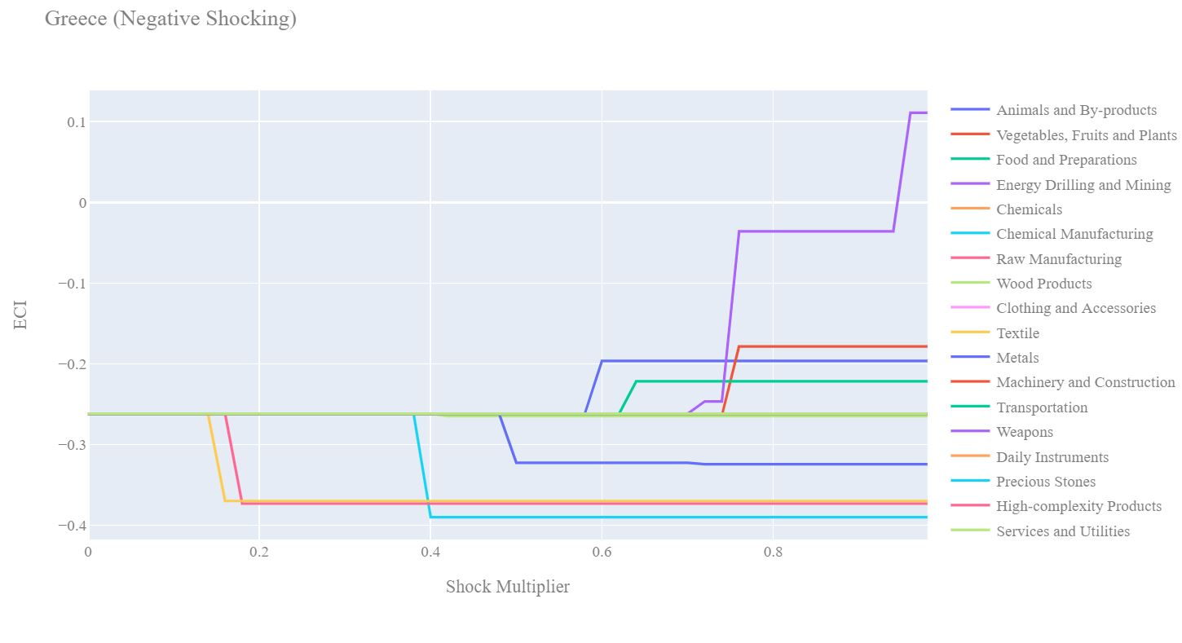
Figure 8b. Greece 2013 (Decremental ECI Sensitivity)

5. Macro-level Predictions

5.1 Structural Optimality Index
Indeed, such choice of prioritization has proven to be a significant factor in deciding the economic outcomes of countries. In order to quantitatively evaluate how effective our development strategies are and how deviations from the suggested developmental path will lead to suboptimal growth results, we define the measure – Structural Optimality Index (SOI) – on a country level as the Adjusted R-Square obtained from regressing the country’s realized industry development over the suggested development strategy. Both strategies are quantified in nature, with the realized development represented by export increase in every major industry groups and the suggested development strategy represented by the opportunity gains of developing the corresponding industry groups as calculated in previous sections. The adjusted R-square from the regression thus provides us with a quantified measure of how the development path adopted by the country has fitted with/differed from calculations on a complexity level.

After obtaining this measure for all countries in our database, we further regress countries’ five-year economic growth, which is defined as the percent increase in GDP (USD), over their SOI. Figure 6 illustrates the regression output, which shows a strong positive correlation between countries’ SOI and their five-year GDP growth, significant at the 1% level and achieving an adjusted R² of 4.5%. In other words, the more a country develops as suggested by calculations on a complexity level, the better economic outcomes it achieves.

Table 18: OLS Regression Results
Dep. Variable: GDP | F-Statistic: 5.963
R²: 0.054 | Prob (F-Stat): 0.0163
Adj R²: 0.045 | No. Observations: 106


Figure 9: Regression of Five-year GDP Growth over SOI

5.2 SOI of Greece and Its Implications
Greece, for instance, has a relatively low level of structural optimality in 2018 as compared with its developed peers; however, in 2021, Greece’s structural optimality improves significantly. As the regression in Figure 7a suggests (the orange curve represents export increase and the blue curve stands for opportunity gain of the corresponding industry), Greece demonstrates a below average level of correlation with the suggested developmental path, having an adjusted R-square of around -1.3%. Greece ranks 70th place among all countries in terms of SOI and has a 5-year growth rate of 10.8% from 2013 to 2018, which is consistent with the regression result in Figure 6. This is in direct contrast to emerging economies such as Turkey, where there is high SOI of around 21.8% and a corresponding GDP growth of 36.7% from 2013 to 2018, making it one of the fastest developing economies during the period. In sum, Greece’s slower economic progress from 2013 to 2018 can be at least partially explained by a mismatched development strategy that demonstrates a considerable level of deviations from our suggested developmental path. In specific, Greece invested heavily in the transportation industry, where there was not much opportunity gain, while it should have focused more on industry groups such as Services and Utilities.
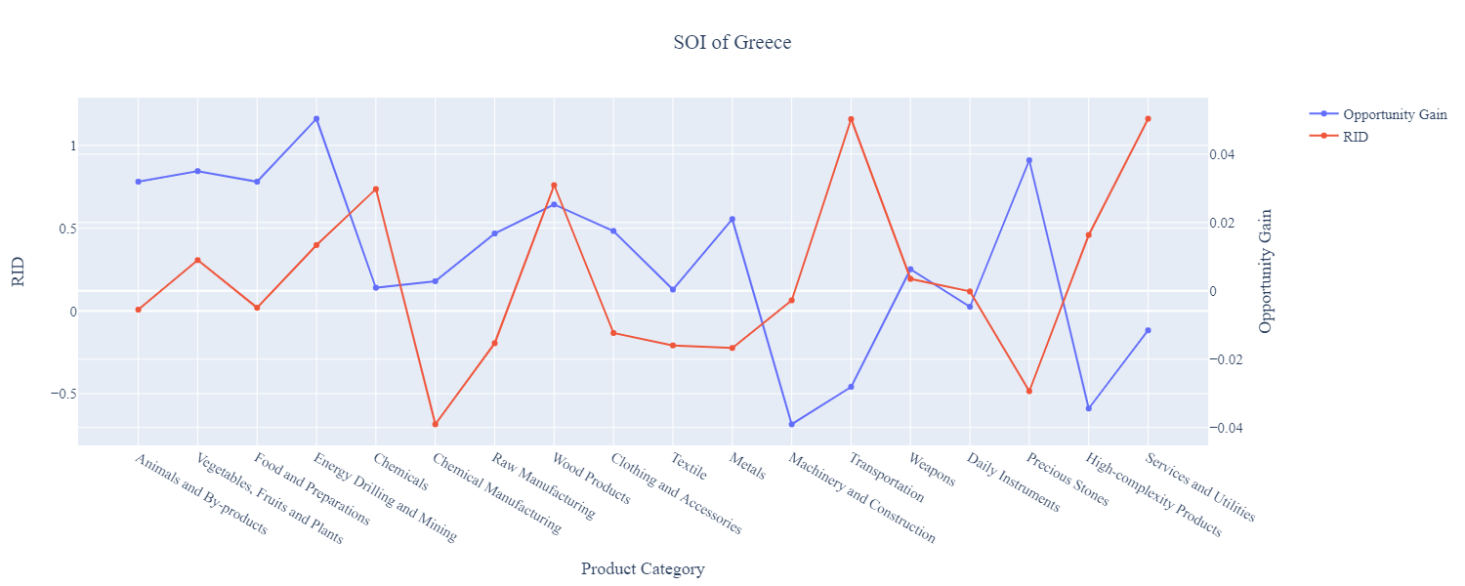
Figure 10a: SOI of Greece (2013-2018)

For the 2019-2021 years, Greece has a strong presence in the Transportation and Services & Utilities industries, but opportunity for further investment is found in the Precious Stones and Energy Drilling & Mining. Greece has seen a growth in GDP over those three years of 3.89%, with an average growth of 2.19%, compared to -1.7% for the average yearly growth for the five years prior. Greece’s ranking in terms of SOI increased to 51st place.

Higher than before, its adjusted R-squared value of 21.54% indicates a much higher correlation between the GDP growth and the implemented development path. Progress is slow on a global scale during this period, but Greece demonstrates a greater ability to adjust to negative economic shocks by improving SOI and increasing GDP growth than it did between 2013 and 2018.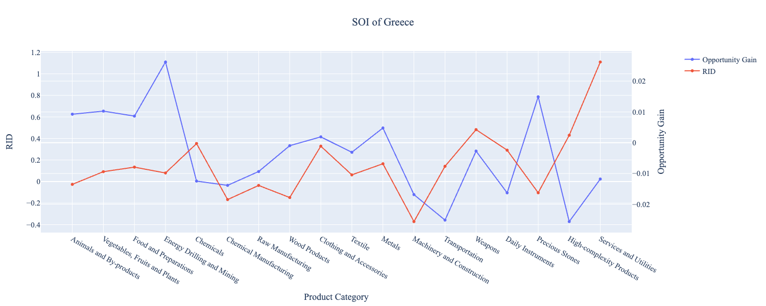
Figure 10b: SOI of Greece (2019-2021)

6. Concluding Remarks
In conclusion, Greece has demonstrated a low level of economic growth in terms of GDP during the period from 2013 to 2018, concurrent with a stagnation in economic complexity as compared with other major European economies. For 2019-2021, the growth in GDP has increased alongside a significant boost in ECI, distinguishing itself from its comparable countries and higher than some of the leading economies in the world.

The level of economic progress during the 2013-2018 period, we believe, can be partially explained through analysis of the economic and product complexity structure of Greece on the industry group level. The product classification system we adopt allows us to measure the realized industry development for various industry groups and to observe that Greece invested heavily in developing Chemical Manufacturing, Precious Stones and Metals during the this period, while its emerging peers and developed economies around the globe adopted much more complex and progressive paths.

Based on our analysis of the opportunity gain and a sensitivity analysis of major industry groups, Greece could have furthered its gains by prioritizing Chemicals, Services and Utilities following 2018. We further note that Greece displayed a slightly mismatched development strategy that indicates a moderate level of structural optimality on the complexity level during the 2013-2018 period, having an adjusted R-square of around -1.3%. Since a significant positive correlation exists between five-year GDP growth and the structural optimality index of an economy as we define and calculate, Greece indeed had a suboptimal growth experience as compared with fast-growing economies both on a regional scale and on a global scale in the period of 2013-2018.

For the period of 2019-2021, Greece performed much stronger than before and compared to other countries in terms of ECI, despite only a moderate increase in GDP relative to comparable countries. We infer that during the COVID-19 period, Greece focused on developing higher complexity industries despite a lower demand for these industries given the global economic downturn. We also note that Greece has increased its investment in the sectors identified earlier, leading to a strong boost from Metals and Daily Instruments industries, leaving some room for strategic improvement. The ECI suggests that greater growth could have been achieved through Precious Stones, followed by Clothing & Accessories and Textile. Still, the observed growth increased the adjusted R-squared value to 21.54% in 2021, demonstrating the pursued strategies contributed to the GDP. With the revised focus, Greece has further potential to advance its economic growth to maintain its position among other countries to continue ongoing economic expansion.

References

Hausmann, R., Hidalgo, C., Bustos, S., Coscia, M., Chung, S., Jimenez, J., Simoes, A. and Yıldırım, M. (2007). The Atlas of Economic Complexity. [online] Atlas.cid.harvard.edu. Available at: http://atlas.cid.harvard.edu/.

Balassa, B., “The Purchasing Power Parity Doctrine - A Reapprais- al,” Journal of Political Economy 72, 584-596 (1964).

Feenstra, R.; Lipsey, R.; Deng, H.; Ma, A. & Mo, H. “World Trade Flows: 1962-2000” NBER working paper 11040. National Bureau of Economic Research, Cambridge MA (2005).

United Nations Commodity Trade Statistics Database (http://comtrade.un.org/db/), accessed in August 2019.

The World Economic Forum, “The global competitiveness report,” (various years).

Barro, R. & Lee, J-W. “A New Data Set of Educational Attainment in the World, 1950-2010,” NBER Working Paper No. 1590 (2010).

Kaufmann, D. & Kraay, A. “Governance Indicators: Where Are We, Where Should We Be Going?” Policy Research Working Paper 4370. Washington, DC: World Bank (2008).

Hanushek, E.A. & Woessmann, L. “The Role of Cognitive Skills in Economic Development,” Journal of Economic Literature 46(3), 607- 668 (2008).

